CCNA Security v2.0
Skills Assessment - A (ASA-5506 / Equiv)
§
This lab has been updated for use on NETLAB+.
www.netdevgroup.com
Topology
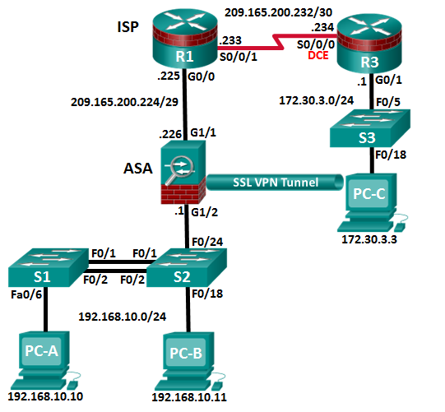
Assessment Objectives
Part 1: Configure PCs and Verify Network Connectivity (5 points, 5 minutes)
Part 2: Configure Secure Router Administrative Access (17 points, 15 minutes)
Part 3: Configure a Zone-Based Policy Firewall (14 points, 10 minutes)
Part 4: Configure an Intrusion Prevention System (15 points, 10 minutes)
Part 5: Secure Layer 2 Switches (22 points, 20 minutes)
Part 6: Configure ASA Basic Management and Firewall Settings (18 points, 15 minutes)
Part 7: Configure the ASA for SSL VPN Remote Access Using ASDM (14 points, 15 minutes)
Scenario
This Skills Assessment (SA) is the final practical exam of student training for the CCNA Security course. The exam is divided into seven parts. The parts should be completed sequentially and signed off by your instructor before moving on to the next part. In Part 1, you will verify that the basic device settings have been preconfigured by the instructor. In Part 2, you will secure a network router using the command line interface (CLI) to configure various IOS features including AAA and SSH. In Part 3 and 4, you will configure a zone-based policy firewall (ZPF) and intrusion prevention using the Cisco IOS intrusion prevention system (IPS) on an integrated service router (ISR) using the CLI. In Part 5, you will configure and secure layer 2 switches using the CLI. In Parts 6 and 7, you will configure the ASA management and firewall settings using the CLI and implement an SSL Remote Access VPN using ASDM.
Required Resources
- 3 Routers (Cisco 1941 with Cisco IOS Release 15.4(3)M2 image with a Security Technology package license or comparable)
- 3 Switches (Cisco 2960 with Cisco IOS Release 15.0(2) lanbasek9 image or comparable)
- 1 ASA 5506 (OS version 9.8(1) and ASDM version 7.8(1) and Base license or comparable)
- 3 PCs (Windows 7 or Windows 8.1, with SSH Client software installed)
- Console cable to configure the Cisco IOS devices via the console ports
- Ethernet and Serial cables as shown in the topology
- Configure PCs and Verify Network Connectivity
Total points: 5
Time: 5 minutes
In the interest of time, R1 and R3 are pre-configured for basic connectivity. You must configure the static IP address information for the PC hosts using the addressing in the topology. You will then verify connectivity.
Configuration Task | Specification | Points
Configure Static IP Addressing on PC-A, PC-B, and PC-C | See Topology for specific settings. | 3
Ping the G0/1 interface on R3 from PC-C. | See Topology for specific settings. | 1/2
Ping interface S0/0/1 on R1 from R3. | See Topology for specific settings. | 1/2
Ping interface G0/0 on R1 from PC-C. | See Topology for specific settings. | 1
Instructor Sign-Off Part 1: ______________________
Points: _________ of 5
Note: Do not proceed to Part 2 until your instructor has signed off on Part 1.

- Configure Secure Router Administrative Access
Total points: 17
Time: 15 minutes
In Part 2, you will secure administrative access on R3 using the CLI. Configuration tasks include the following:
Configuration Item or Task | Specification | Points
Set minimum password length. | Minimum Length: 10 characters | 1
Assign and encrypt a privileged EXEC password. | Password: cisco12345  Encryption type: 9 (scrypt) | 1
Add a user in the local database for administrator access. | Username: Admin01  Privilege level: 15  Encryption type: 9 (scrypt)  Password: admin01pass | 1
Configure an MOTD banner. | Unauthorized Access is Prohibited! | 1/2
Disable HTTP server services. |  | 1/2
Configure SSH. | Domain name: ccnassecurity.com  RSA keys size: 1024  Version: 2  Timeout: 90 seconds  Authentication retries: 2 | 4
Configure VTY lines to allow SSH access. | Allow only SSH access | 1
Configure the AAA authentication and authorization settings. | Enable AAA  Use local database as default setting. | 2
Configure NTP. | Authentication key: NTPpassword  Encryption: MD5  Key: 1  NTP server: 209.165.200.233  Configure for periodic calendar updates. | 4
Configure syslog. | Enable timestamp service to log the date and time in milliseconds.  Send syslog messages to: 172.30.3.3.  Set message logging severity level to: Warnings. | 2

Note: Before proceeding to Part 3, ask your instructor to verify R3’s configuration and functionality.
Instructor Sign-Off Part 2: ______________________
Points: _________ of 17

- Configure a Zone-Based Policy Firewall
Total points: 14
Time: 10 minutes
In Part 3, you will configure a ZPF on R3 using the CLI. Configuration tasks include the following:
Configuration Item or Task | Specification | Points
Create security zone names. | Inside zone name: INSIDE  Outside zone name: INTERNET | 2
Create an inspect class map. | Class map name: INSIDE_PROTOCOLS  Inspection type: match-any  Protocols allowed: tcp, udp, icmp | 3
Create an inspect policy map. | Policy map name: INSIDE_TO_INTERNET  Bind the class map to the policy map.  Matched packets should be inspected. | 3
Create a zone pair. | Zone pair name: IN_TO_OUT_ZONE  Source zone: INSIDE  Destination zone: INTERNET | 2
Apply the policy map to the zone pair. | Zone pair name: IN_TO_OUT_ZONE  Policy map name: INSIDE_TO_INTERNET | 2
Assign interfaces to the proper security zones. | Interface G0/1: INSIDE  Interface S0/0/0: INTERNET | 2

Troubleshoot as necessary to correct any issues.
Note: Before proceeding to Part 4, ask your instructor to verify your ZPF configuration and functionality.
Instructor Sign-Off Part 2: ______________________
Points: _________ of 14

- Configure an Intrusion Prevention System
Total points: 15
Time: 10 minutes
In Part 4, you will configure an IPS on R3 using the CLI. Configuration tasks include the following:
Configuration Item or Task | Specification | Points
Create an IPS directory on flash. | Directory name: IPSDIR  Note: If the directory already exists, delete the directory and recreate it. | 1
Copy and paste the crypto key file into R3’s running-configuration. | crypto key pubkey-chain rsa  named-key realm-cisco.pub signature  key-string  30820122 300D0609 2A864886 F70D0101 01050003 82010F00 3082010A 02820101  00C19E93 A8AF124A D6CC7A24 5097A975 206BE3A2 06FBA13F 6F12CB5B 4E441F16  17E630D5 C02AC252 912BE27F 37FDD9C8 11FC7AF7 DCDD81D9 43CDABC3 6007D128  B199ABCB D34ED0F9 085FADC1 359C189E F30AF10A C0EFB624 7E0764BF 3E53053E  5B2146A9 D7A5EDE3 0298AF03 DED7A5B8 9479039D 20F30663 9AC64B93 C0112A35  FE3F0C87 89BCB7BB 994AE74C FA9E481D F65875D6 85EAF974 6D9CC8E3 F0B08B85  50437722 FFBE85B9 5E4189FF CC189CB9 69C46F9C A84DFBA5 7A0AF99E AD768C36  006CF498 079F88F8 A3B3FB1F 9FB7B3CB 5539E1D1 9693CCBB 551F78D2 892356AE  2F56D826 8918EF3C 80CA4F4D 87BFCA3B BFF668E9 689782A5 CF31CB6E B4B094D3  F3020301 0001  quit | 1
Create an IPS rule. | IPS rule name: IOSIPS | 1
Set the storage location for the IPS signatures. | Location: IPSDIR on flash | 1
Enable IPS SDEE event notification. | Enable HTTP server services.  Enable SDEE notification services. | 1
Enable IPS syslog support. |  | 1
Retire all signatures in the all category. | Category: all | 2
Un-retire the ios_ips basic category signatures. | Category: ios_ips basic | 2
Apply the IPS rule to the interface. | Interface: S0/0/0  Direction: in | 2
Copy the S854 signature from PC-C. | Protocol: TFTP  IP Address of TFTP server: 172.30.3.3  Signature: IOS-S854-CLI.pkg  Compile signatures after they are loaded: idconf | 3
Note: Before attempting the TFTP copy, the Tftpd32 software on PC-C needs to be running with the directory set to the location of the file: IOS-S854-CLI.pkg.
Troubleshoot as necessary to correct any issues.
Note: Before proceeding to Part 5, ask your instructor to verify your IPS configuration and functionality.
Instructor Sign-Off Part 4: ______________________
Points: _________ of 15

- Secure Layer 2 Switches
Total points: 22
Time: 20 minutes
Note: Not all security features in this part of the exam will be configured on all switches. However, in a production network, all security features will be configured on all switches. In the interest of time, the security features are configured on only S2, except where noted.
In Part 5, you will configure security settings on S2 using the CLI. Configuration tasks include the following:
Configuration Item or Task | Specification | Points
Assign and encrypt a privileged EXEC password. | Switch: S2  Password: cisco12345  Encryption type: 9 (scrypt) | 1/2
Add a user in the local database for administrator access. | Switch: S2  Username: Admin01  Privilege level: 15  Encryption type: 9 (scrypt)  Password: admin01pass | 1
Configure an MOTD banner. | Switch: S2  Banner: Unauthorized Access is Prohibited! | 1/2
Disable HTTP and HTTP secure server. | Switch: S2 | 1
Configure SSH. | Switch: S2  Domain name: ccnassecurity.com  RSA keys size: 1024  Version: 2  Timeout: 90 seconds  Authentication retries: 2 | 2
Configure the VTY lines to allow SSH access. | Switch: S2  Allow only SSH access. | 1/2
Configure the AAA authentication and authorization settings. | Switch: S2  Enable AAA  Use local database as default setting. | 2
Create the VLAN list. | Switches: S1 & S2  VLAN: 2, Name: NewNative  VLAN: 10, Name: LAN  VLAN: 99, Name: Blackhole | 1/2
Configure the trunk ports. | Switches: S1 & S2  Interfaces: F0/1, F0/2  Native VLAN: 2  Prevent DTP. | 2
Disable trunking. | Switch: S2  Ports: F0/18, F0/24  VLAN assignment: 10 | 2
Enable PortFast and BPDU guard. | Switch: S2  Ports: F0/18, F0/24 | 2
Configure basic port security. | Switch: S2  Port: F0/18  Maximum limit: 1  Remember the MAC address.  Violation Action: Shutdown | 3
Disable unused ports on S2, and assign ports to VLAN 99. | Switch: S2  Ports: F0/3-17, F0/19-23, G0/1-2 | 1
Configure Loop guard. | Switch: S2  Loop guard: Default | 1
Configure DHCP snooping. | Enable DHCP snooping globally  Enable DHCP for VLAN: 10  DHCP trusted interface: F0/24 | 3
NETLAB+ Note: Use a Maximum limit of 2 when configuring basic port security. Otherwise, the hidden Control Switch will cause a violation to occur and the port will be shutdown.
Troubleshoot as necessary to correct any issues.
Note: Before proceeding to Part 6, ask your instructor to verify your switch configuration and functionality.
Instructor Sign-Off Part 5: ______________________
Points: _________ of 22

- Configure ASA Basic Management and Firewall Settings
Total points: 18
Time: 15 minutes
Note: By default, the privileged EXEC password is blank. Press Enter at the password prompt.
In Part 6, you will configure the ASA’s basic setting and firewall using the CLI. Configuration tasks include the following:
Configuration Item or Task | Specification | Points
Configure the ASA hostname. | Name: CCNAS-ASA | 1/2
Configure the domain name. | Domain name: ccnasecurity.com | 1/2
Configure the privileged EXEC password. | Password: cisco12345 | 1/2
Add a user in the local database with administrator console access. | User: Admin01  Password: admin01pass | 1/2
Configure Interface Gig1/2 | Gig1/2  Name: inside  IP address: 192.168.10.1  Subnet mask: 255.255.255.0  Security level: 100 | 3
Configure Interface Gig1/1 | Gig1/1  Name: outside  IP address: 209.165.200.226  Subnet mask: 255.255.255.248  Security level: 0 | 4
Configure the AAA to use the local database for SSH user authentication. |  | 1
Generate an RSA key pair to support the SSH connections. | Key: RSA  Modulus size: 1024 | 1
Configure the ASA to accept SSH connections from hosts on the inside LAN. | Inside network: 192.168.10.0/24  Timeout: 10 minutes  Version: 2 | 1
Configure the default route. | Default route IP address: 209.165.200.225 | 1
Configure the ASDM access to the ASA. | Enable HTTPS server services.  Enable HTTPS on the inside network. | 2
Create a network object to identify internal addresses for PAT. Dynamically bind interfaces by using the interface address as the mapped IP. | Object name: INSIDE-NET  Subnet: 192.168.10.0/24  Interfaces: inside, outside | 2
Modify the default global policy to allow returning ICMP traffic through the firewall. | Policy-map: global_policy  Class: inspection_default  Inspect: icmp | 1

Troubleshoot as necessary to correct any issues.
Note: Before proceeding to Part 7, ask your instructor to verify your ASA configuration and functionality.
Instructor Sign-Off Part 6: ______________________
Points: _________ of 18
- Configure the ASA for SSL VPN Remote Access Using ASDM
Total points: 14
Time: 15 minutes
In Part 7, you will configure an AnyConnect SSL remote access VPN on the ASA using ASDM. You will then use a browser on PC-C to connect and download the Cisco AnyConnect Secure Mobility Client software located on the ASA. After the software has downloaded, you will manually install the AnyConnect software to PC-C and use it to establish a remote SSL VPN connection to the ASA.
  - Configure SSL VPN settings on the ASA using the ASDM from PC-B.
Configuration Item or Task | Specification | Points
Use a browser on PC-B, and connect to the ASA. | Connection: HTTPS  IP address: 192.168.10.1  Username: Admin01  Password: admin01pass  Note: You will need to accept all security messages and/or add the ASA IP address to the allowed list of IP addresses in Java.  If the “Run ASDM” button via Java is not accessible, access your ASA via https://<ip_address>/admin/public/asdm.jnlp to download the JNLP file and then open the file to continue using ASDM. | 1
Use the AnyConnect VPN Wizard to configure the ASA to accept SSL VPN connections from the Cisco AnyConnect Secure Mobility Client. | Connection profile name: ANYCONNECT-SSL-VPN  VPN access interface: outside  VPN protocols: SSL only.  Client images: anyconnect-win-4.1.00028-k9.pkg  Username: VPNuser  Password: VPNuserpa55  IP address pool name: VPN-POOL  IP address pool starting address: 192.168.10.201  IP address pool ending address: 192.168.10.210  IP address pool subnet mask: 255.255.255.0  DNS server: 10.20.30.40  Domain name: ccnasecurity.com  Exempt VPN traffic from NAT: Enable  Inside interface: inside  Local network: any4 | 7
Use a browser on PC-B to establish an ASDM session to the ASA. After the session is established, use the AnyConnect VPN Wizard to configure the ASA to allow SSL VPN client connections. Configuration parameters include the following:

  - Establish an SSL VPN connection to the ASA from PC-C
To establish an SSL VPN connection to the ASA, you will need to use a browser on PC-C to download the Cisco AnyConnect Secure Mobility Client software from the ASA. After the software is downloaded, you will install the AnyConnect software to PC-C and then establish an SSL VPN connection to the ASA. The steps required are as follows:
Configuration Item or Task | Specification | Points
Use a browser on PC-C. Connect to the ASA. Download the Cisco AnyConnect Secure Mobility Client software to the PC. | Connection: HTTPS  IP address: 209.165.200.226  Username: VPNuser  Password: VPNuserpa55  Note: You will need to accept all security messages. If authentication fails troubleshoot below. | 2
Download and install the Cisco AnyConnect Secure Mobility Client. After installation is complete the AnyConnect SSL VPN session should be established automatically. | Accept all security warning messages.  If the Untrusted Server Blocked! window appears. Click Change Setting to allow the connection to ASA.  When asked to change PC settings to allow AnyConnect Client to be installed, click Yes. | 2
Verify the SSL VPN has been established to the ASA using ASDM from PC-B. |  | 2
Troubleshoot as necessary to correct any issues.
Note: If the AnyConnect client fails authentication, reset the password.
Configuration > Remote Access VPN > Local Users > REMOTEuser > Edit > Identity > Change user password (retype in the correct username and password combo). Click OK followed by clicking Apply.
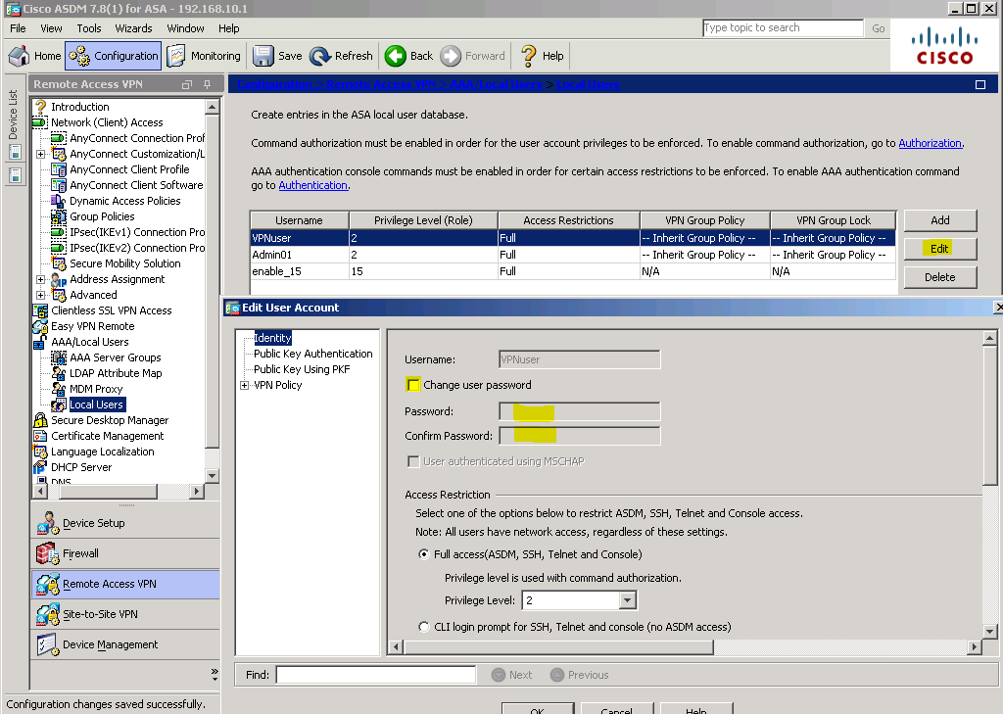
Instructor Sign-Off Part 7: ______________________
Points: _________ of 14
Router Interface Summary
Router Interface Summary
Router Model | Ethernet Interface #1 | Ethernet Interface #2 | Serial Interface #1 | Serial Interface #2
1800 | Fast Ethernet 0/0 (F0/0) | Fast Ethernet 0/1 (F0/1) | Serial 0/0/0 (S0/0/0) | Serial 0/0/1 (S0/0/1)
1900 | Gigabit Ethernet 0/0 (G0/0) | Gigabit Ethernet 0/1 (G0/1) | Serial 0/0/0 (S0/0/0) | Serial 0/0/1 (S0/0/1)
2801 | Fast Ethernet 0/0 (F0/0) | Fast Ethernet 0/1 (F0/1) | Serial 0/1/0 (S0/1/0) | Serial 0/1/1 (S0/0/1)
2811 | Fast Ethernet 0/0 (F0/0) | Fast Ethernet 0/1 (F0/1) | Serial 0/0/0 (S0/0/0) | Serial 0/0/1 (S0/0/1)
2900 | Gigabit Ethernet 0/0 (G0/0) | Gigabit Ethernet 0/1 (G0/1) | Serial 0/0/0 (S0/0/0) | Serial 0/0/1 (S0/0/1)
Note: To find out how the router is configured, look at the interfaces, identify the type of router, and how many interfaces the router has. There is no way to effectively list all of the combinations of configurations for each router class. This table includes identifiers for the possible combinations of Ethernet and Serial interfaces in the device. This table does not include any other type of interface, even though a specific router may contain one. An example of this might be an ISDN BRI interface. The string in parenthesis is the legal abbreviation that can be used in Cisco IOS commands to represent the interface.

